Pet Owner Information
Name
Street Address
City |  | State |  | Zip |  |  | Email
Home Phone |  |  |  | Cell Phone
Emergency Contact Information
Name
Home Phone |  |  |  | Cell Phone
Veterinarian Information
Name |  |  |  | Phone
Pet Name | Breed  &  Color | M / F | Age | Medical  Conditions | Feeding  Instructions | Other Needs | Last  Flea & Tick  Treatment
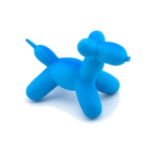
Signature:_________________________
Date:_______________
Bed & Biscuit does not accept personal checks.
Please pay by cash or credit card.
Bed & Biscuit Pet Resort
5525 S. State Rt. 69
Humbolt, AZ 86329
Registration Form

